

UNIVERSIDAD:
UNIVERSIDAD POPULAR AUTÓNOMA DEL ESTADO DE PUEBLA (UPAEP)

ASIGNATURA:
Ingeniería de Sistemas 101-140-ISW225-001

MAESTRO:
Jorge Rafael Aguilar Cisneros

2_2_D_Project_T

ALUMNO:
Miguel Angel Hernández Camacho- ID: 3421326
Enrique Alfonso Gracián Castro - ID: 3507183
Gustavo Enrique Martinez Moreno - ID: 3448119
Rodrigo Samuel Bernal Moreno - ID: 3459730
Lucio Emiliano Ruiz Sepulveda - ID: 3509080
Jesús Pérez Rodríguez - ID: 3504872

FECHA:
19/02/2026

Index

1. Stakeholder needs / Requirements: Modeling Elements 3
1.1 Actors 3
1.2 Main Use Cases 3
1.3 Operational Concepts 4
1.3.1 System Activity Diagrams 4
1.3.2 System Sequence Diagrams 6
1.4 High-Level Requirements ("Black-Box" view) 8
2. System Requirements 10
2.1 Functional Requirements (FR) 10
2.2 Non-Functional Requirements (NFR) 10
3 System Architecture & Structure (The "What"). Purpose 12
3.1 System Context (Block Definition Diagram - BDD) 12
3.2 System Decomposition (BDD) 12
3.3 Internal Block Diagram (IBD) 13
4. System Behavior (The "How") 14
4.1 State Machine Diagram 14
4.2 Mapping Behavior to Requirements 15
5. Parametrics & Constraints (The "How Well") 16
6. Verification & Validation (V&V) 16

1. Stakeholder needs / Requirements: Modeling Elements

1.1 Actors
- Visitor: The main actor who initiates the interaction when approaching the office.
- Office Owner: The beneficiary of the system that consumes the information collected by AISSA.
- Administrator: The technical person in charge of ensuring that the Raspberry Pi 5 and the AI Kit work correctly.

1.2 Main Use Cases
- Detect Presence (UC1): The system uses the RPi Camera Module 3 and the AI Kit to identify a human figure in the field of view. It is the necessary condition to activate the interface.
- Interact via Voice (UC2): The core of the human-machine experience. It includes natural language processing (NLP) to understand the visitor and respond through speech synthesis (TTS).
- Leave Voice Message (UC4): If the owner is not available, the system captures the visitor's audio. This use case includes the automatic task of transcribing speech to text (STT) for easier later reading.
- View Transcribed Messages (UC5): The owner accesses the visitor log to read the messages and view the captured photo of the visitor.
- Monitor Hardware Status (UC7): Administrator monitors temperatures (critical on the AI Pi 5) and memory usage of the Raspberry Pi 16GB.

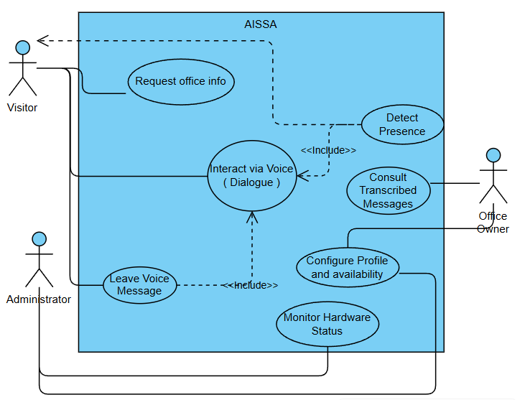
The Use Case Diagram for AISSA illustrates how different actors interact with the system boundaries to achieve specific goals. "Modeling system behavior through use cases provides a clear functional roadmap that guides the subsequent architectural design" (OMG, 2024). In our view, the integration of these use cases ensures that every hardware component in the Raspberry Pi 5 setup is mapped to a specific user value.

1.3 Operational Concepts
From the user’s perspective, AISSA will be installed in the wall near the office entrance.
AISSA will automatically detect the user and greet with “Hello, May I help you?”, from that, the user will be able to maintain a fluent conversation to either obtain contact information or leave a message to the office owner

The main objective is to optimize communication between a visitor and the office owner while the owner is unavailable.

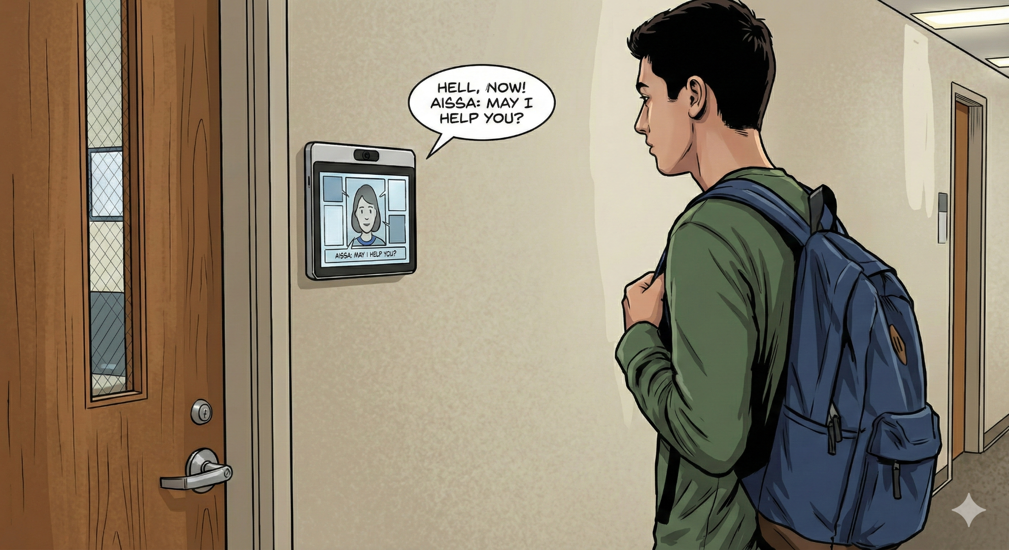

1.3.1 System Activity Diagrams

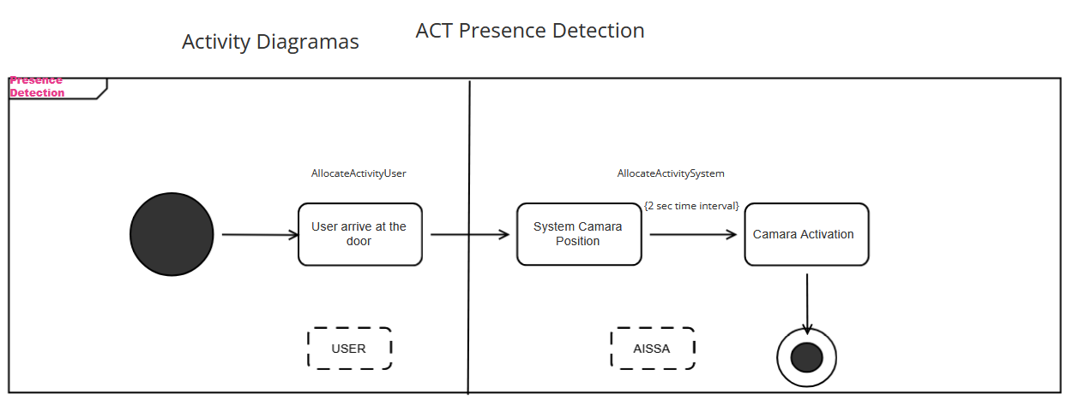

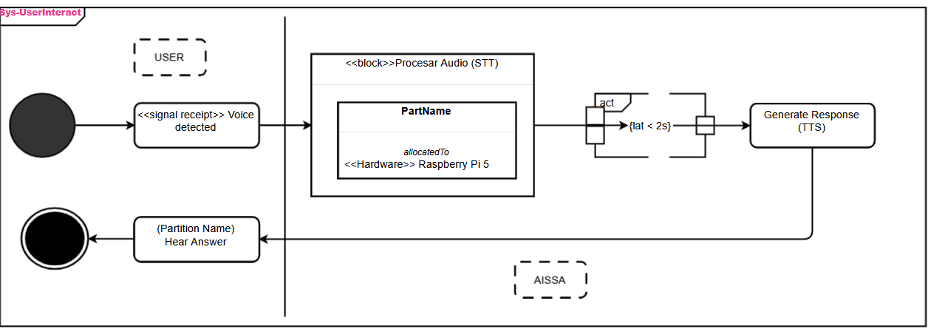
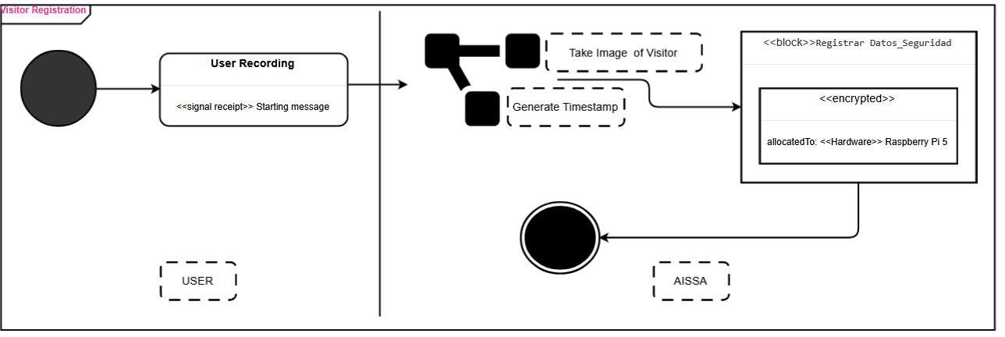
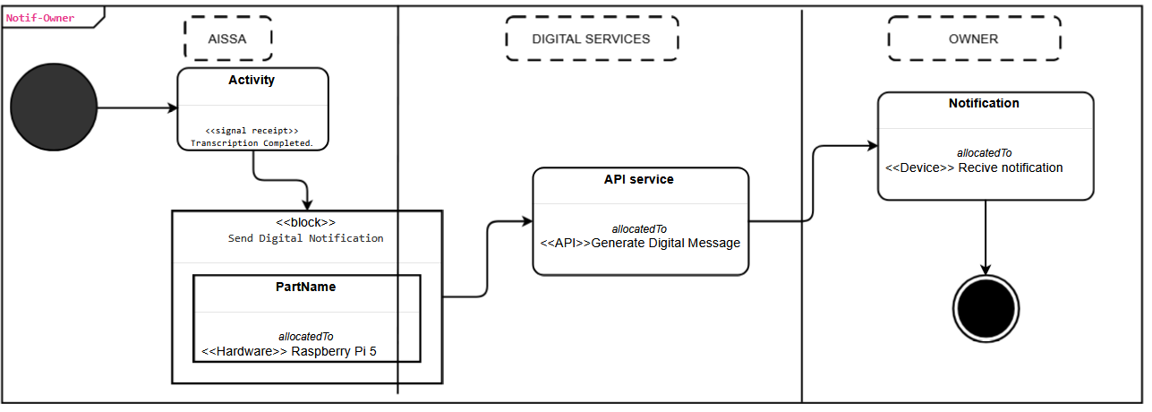
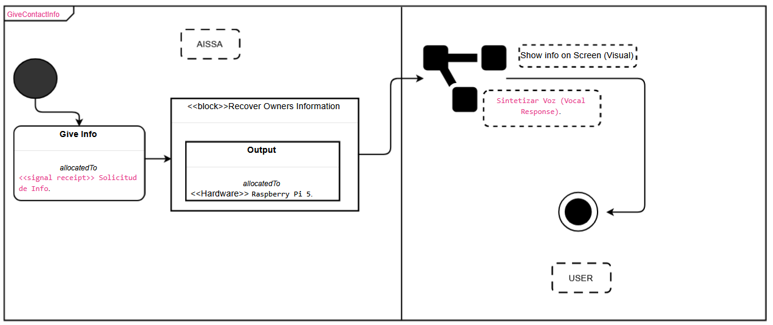

1.3.2 System Sequence Diagrams
Case: Presence Detection
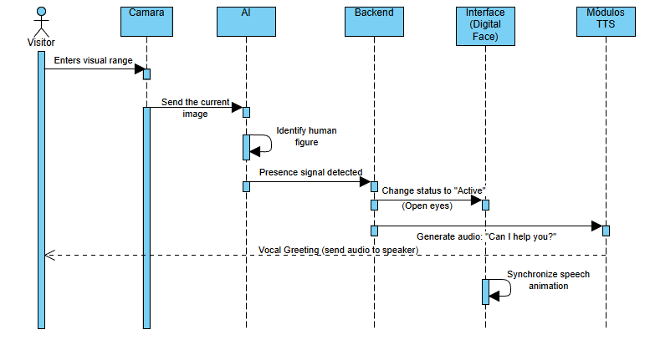
Case: Contact Information
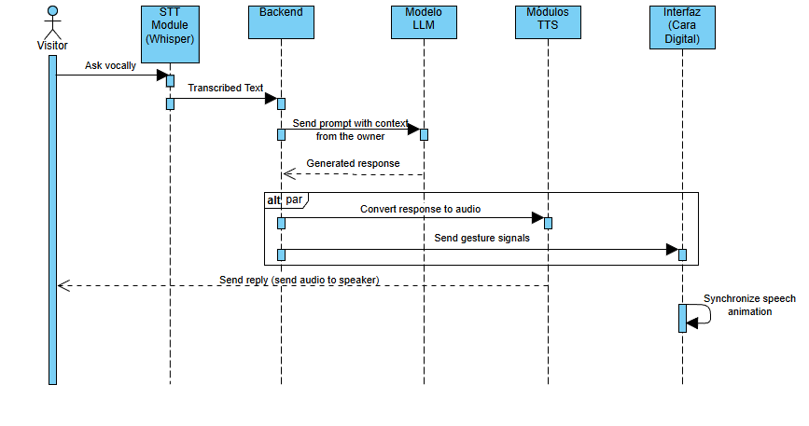

Case: Visitor Registration
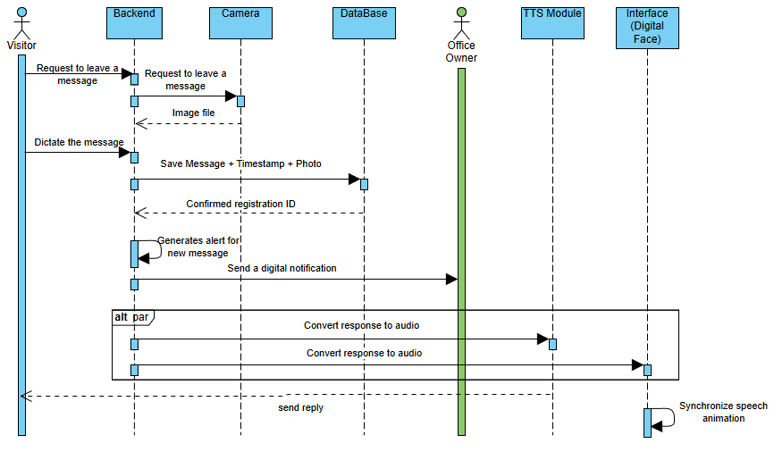
Case: Consult Transcribed Messages / Edit data
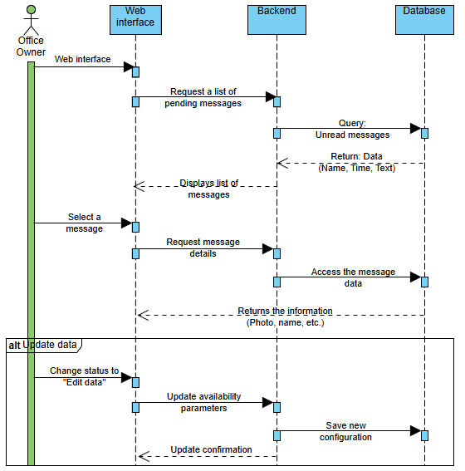
Case: Edit data
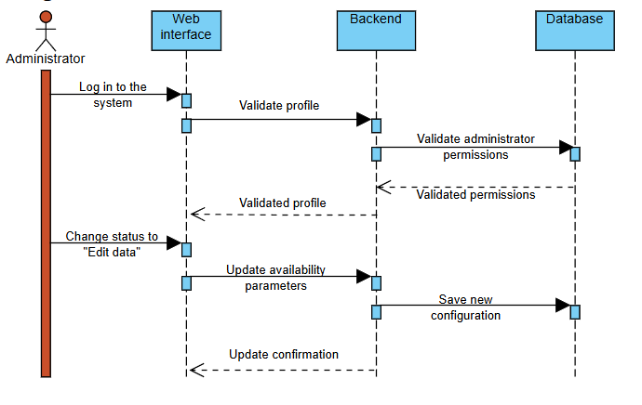
Case: Monitor Hardware Status
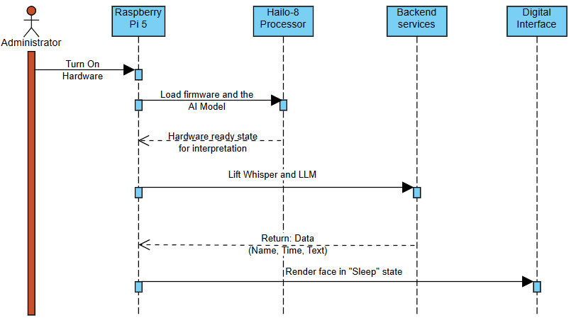

1.4 High-Level Requirements ("Black-Box" view)
The black box diagram for AISSA illustrates the connections between the components needed for the optimal use and functionality of the system.
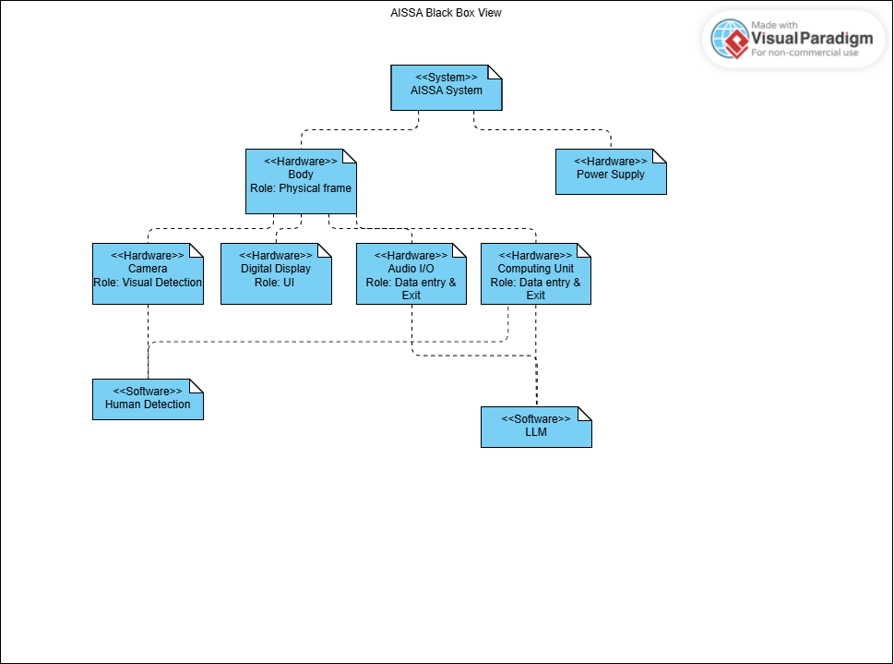
1. 5 System requirements diagram

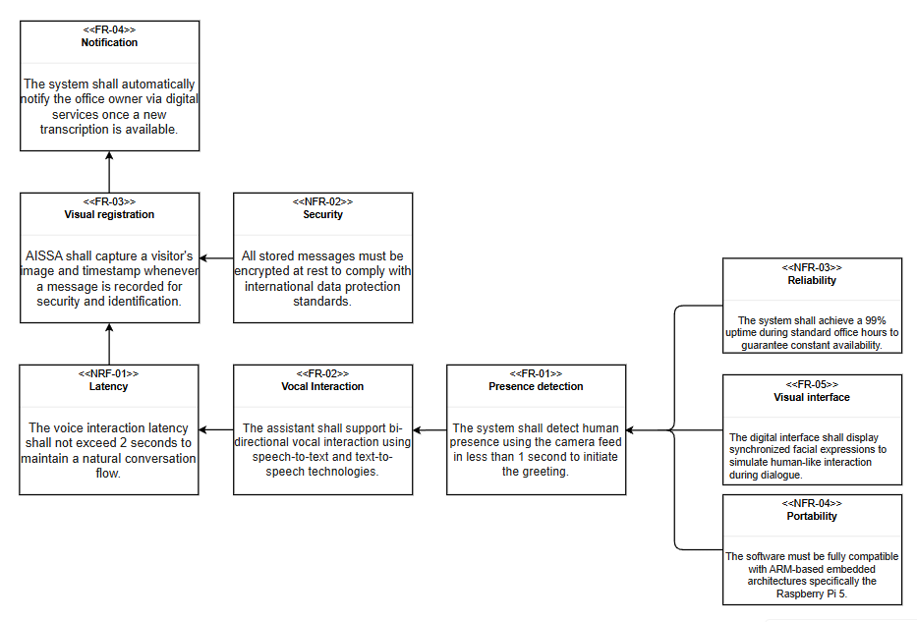

2. System Requirements

2.1 Functional Requirements (FR)
ID | Name | Description
FR-01 | Presence Detection | The system shall detect human presence using the camera feed in less than 1 second to initiate the greeting.
FR-02 | Vocal Interaction | The assistant shall support bi-directional vocal interaction using speech-to-text and text-to-speech technologies.
FR-03 | Visitor Registration | AISSA shall capture a visitor's image and timestamp whenever a message is recorded for security and identification.
FR-04 | Notification | The system shall automatically notify the office owner via digital services once a new transcription is available.
FR-05 | Visual Interface | The digital interface shall display synchronized facial expressions to simulate human-like interaction during dialogue.
FR-06 | Contact Information | The system shall provide predefined information about the office owner (name, role, office hours, alternative contact info)

2.2 Non-Functional Requirements (NFR)
ID | Category | Specification
NFR-01 | Latency | The voice interaction latency shall not exceed 2 seconds to maintain a natural conversation flow.
NFR-02 | Security | All stored messages must be encrypted at rest to comply with international data protection standards.
NFR-03 | Reliability | The system shall achieve a 99% uptime during standard office hours to guarantee constant availability.
NFR-04 | Portability | The software must be fully compatible with ARM-based embedded architectures specifically the Raspberry Pi 5.

3 System Architecture & Structure (The "What"). Purpose

3.1 System Context (Block Definition Diagram - BDD)
Purpose: Define the boundaries of the System of Interest (SoI) and its interactions with the external environment.
The AISSA system acts as the core interaction hub in the office environment. In this context diagram, we identify three primary actors and two support systems:
- Visitor: Initiates physical and vocal interaction.
- Office Owner: Receives notifications and manages configurations.
- Administrator: Performs technical maintenance and updates.
- External API: Cloud services for advanced processing or digital services.
- Power Grid: Energy supply via USB-C.
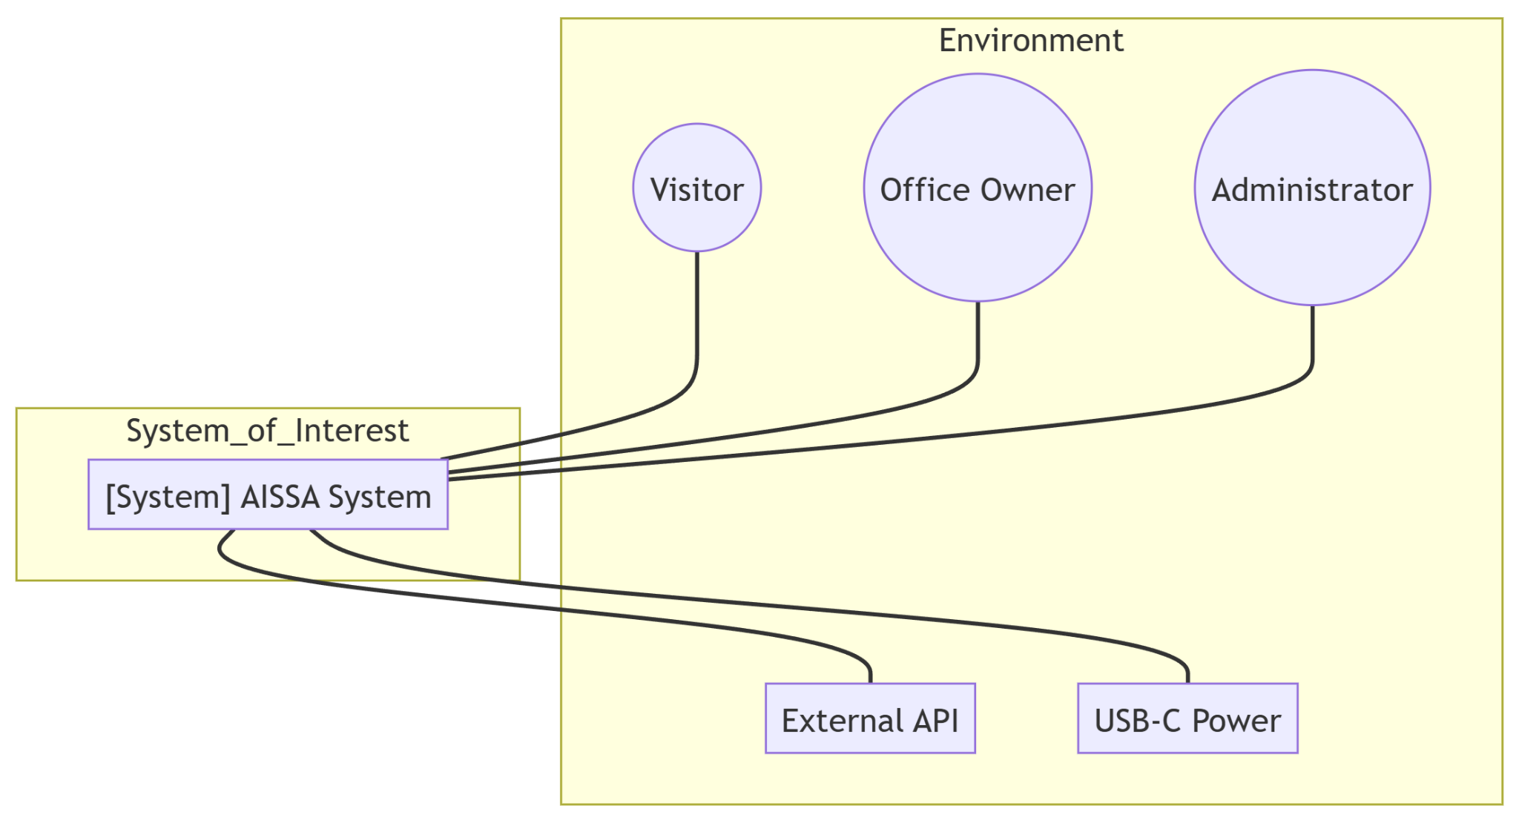

3.2 System Decomposition (BDD)
Purpose: Break down the internal hierarchy of AISSA into logical and physical blocks.
The architecture is divided into three main domains to ensure modularity:
- Hardware: Based on a Raspberry Pi 5 (16GB RAM) for central computing, assisted by an AI Kit (Hailo-8) dedicated to neural network acceleration. Capture is performed via a Camera Module 3, and audio through a USB I/O system.
- Software: Composed of a Natural Language Processing (NLP) engine for the local LLM, a Perception (Vision) module for face tracking, and a User Interface (UI Face) for visual feedback.
- Data: Management of user preferences and encrypted message logs to comply with security requirement NFR-02.
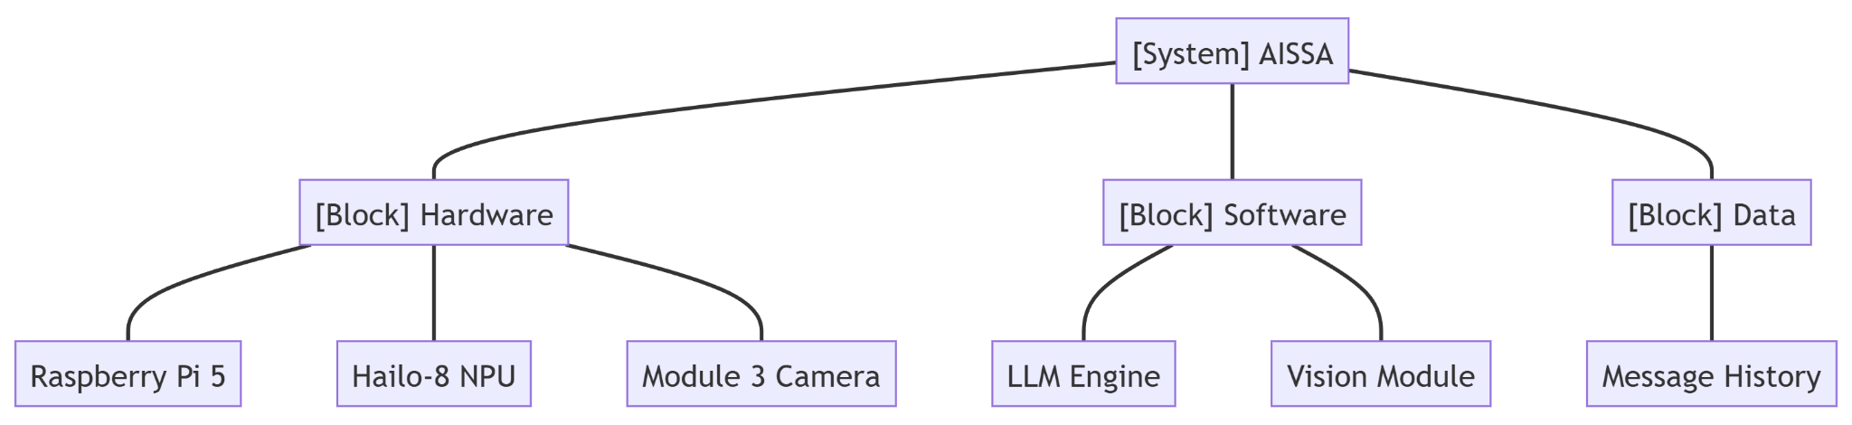

3.3 Internal Block Diagram (IBD)
Purpose: Show the physical connections and data flows between the component ports.
This diagram details how the internal parts communicate:
- Camera to RPi 5: Raw video flow through the MIPI CSI port.
- RPi 5 to AI Kit: Bi-directional communication via PCIe for real-time vision inference with low latency (NFR-01).
- Audio I/O: USB interface for microphone input and speaker output.
- Visual Interface: Graphic data output to the touch screen via HDMI/DSI to display facial expressions (FR-05).
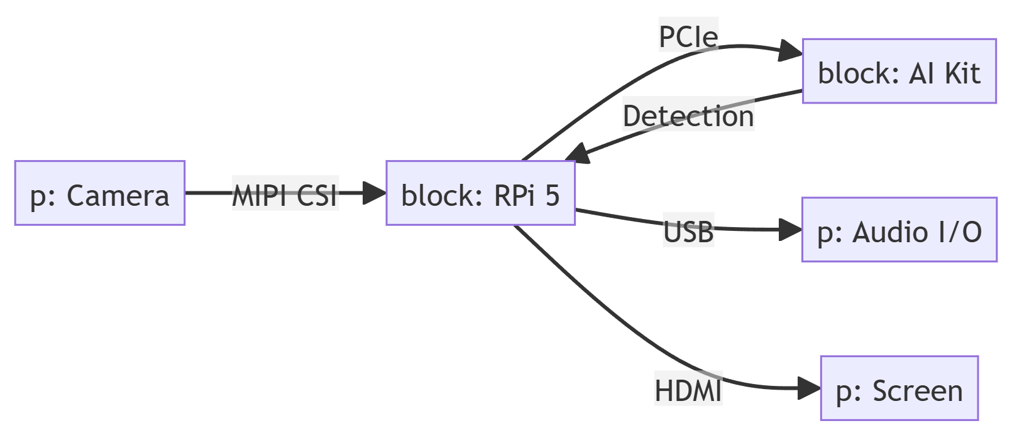

4. System Behavior (The "How")

4.1 State Machine Diagram
Purpose: Define the system's logical states and transitions based on events.
The AISSA lifecycle is designed to optimize power consumption and user response:
- Standby: The system remains in a low-power state, using only vision polling to detect presence.
- Active: Upon detecting a human (FR-01), the system activates the visual interface and greets the visitor.
- Conversing: An active interaction state where voice is processed and responses are generated using the LLM.
- Recording: If the office owner is unavailable, the system automatically transitions to this state to capture a message (FR-03).
- Notifying: After saving the message, an alert is sent to the owner, and the system returns to Standby.
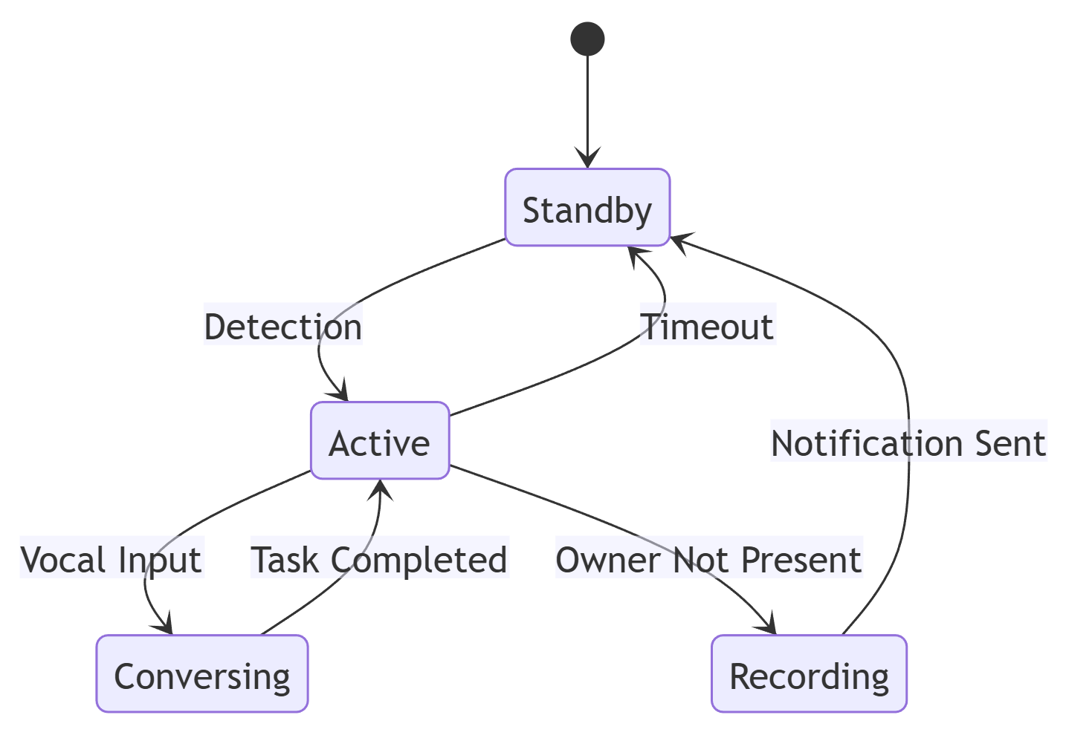

4.2 Mapping Behavior to Requirements
The modeled behavior ensures compliance with the requirements defined in Delivery 1:
- Presence Detection: The transition from Standby to Active occurs in less than 1 second thanks to the Hailo-8 accelerator.
- Conversation Latency: Local processing on the RPi 5 ensures that the vocal response does not exceed 2 seconds (NFR-01).
- Security: The Notifying state is only reached after verifying that the message has been encrypted within the Data block.

5. Parametrics & Constraints (The "How Well")
Purpose: Perform quantitative analysis to ensure the system's performance, power consumption, and processing speed meet the established requirements.

Description: The Parametrics and Constraints diagram utilizes SysML modeling elements to verify that the AISSA system operates within its defined physical and technical boundaries. The core component is the SystemPerformanceContext (Analysis Context), which drives the performance verification tools.

Within this context, we analyze the main AISSASystem block, evaluating specific variables such as CPU and GPU utilization (from the RPi 5 and Hailo-8), processing time, and network latency. The diagram introduces two critical Constraint Blocks:
- PowerConstraint: Contains the mathematical boundaries for power consumption. It calculates the total power based on utilization factors and guarantees the total load stays below the 50W hardware limit (as indicated by the system constraints).
- LatencyConstraint: Calculates the total response time by adding the processing time and network latency, ensuring the system strictly adheres to the <100ms response requirement for a natural human-machine interaction.
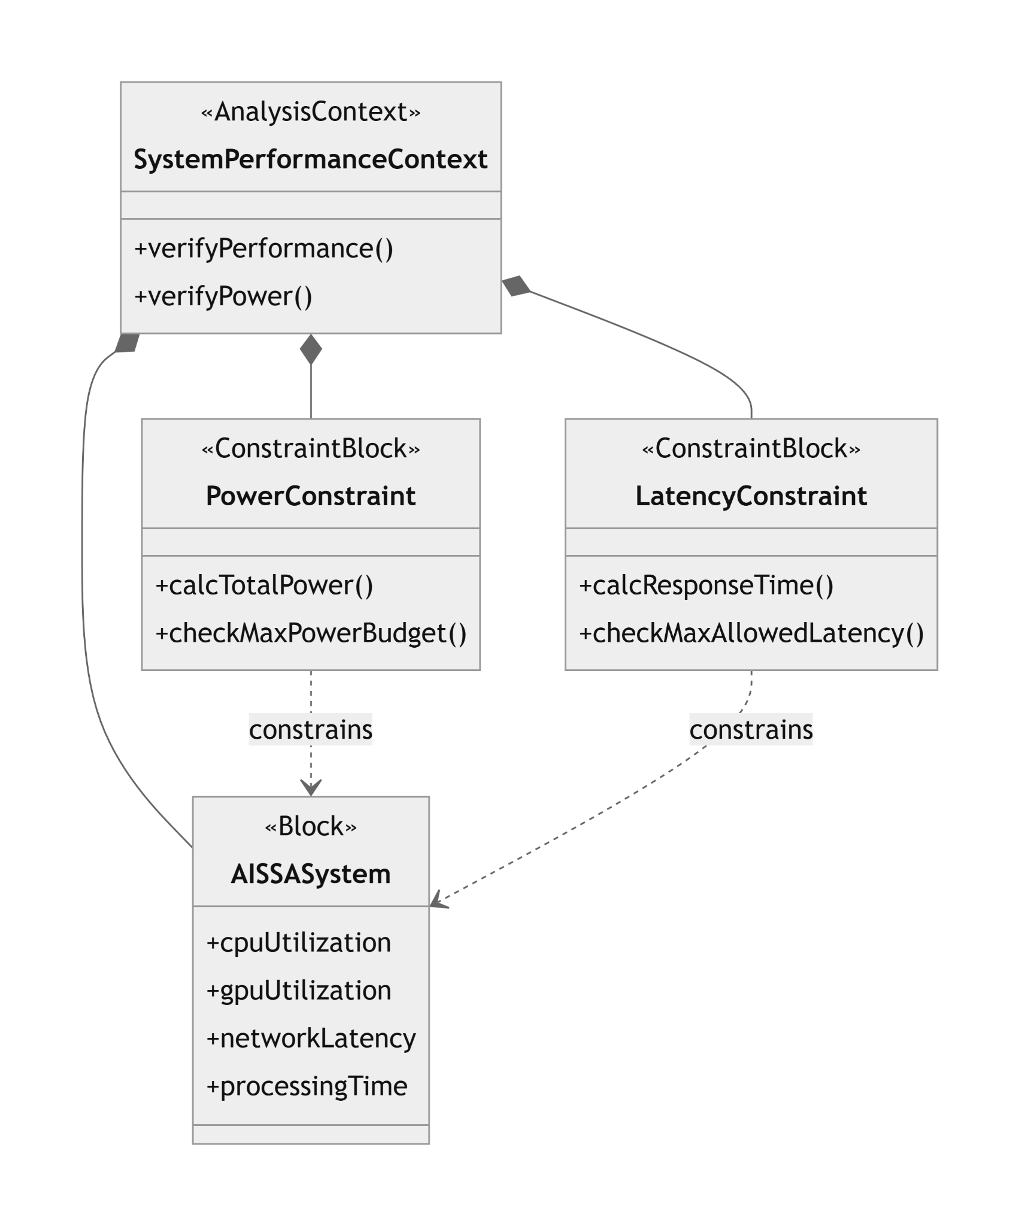

6. Verification & Validation (V&V)
Purpose: Ensure the system is built correctly and explicitly meets the stakeholder needs and previously defined criteria.

Description: The Verification & Validation (V&V) diagram provides clear traceability from the High-Level Requirements down to the specific Test Cases used to validate them. Modeled using a SysML Requirement Diagram, this structure explicitly maps the verification requirements through logical relationships.

- Requirement Traceability: The diagram highlights two critical system requirements: "LowLatency" (Req ID: 1, high risk) and "PowerEfficiency" (Req ID: 2, medium risk).
- Test Case Allocation: Modeled as elements, LatencyTest and PowerTest represent the testing procedures designed to validate system behavior.
- Verification Relationship: The verifies relationship explicitly links each test case to its corresponding requirement, proving that the acceptance criteria are met. This ensures that the AISSA system is not only designed theoretically but includes a clear testing roadmap for real-world validation of its 100ms latency and 50W consumption limits.

